Appendix A



Pension Fund Annual Report
2010-11

London Borough of Harrow
Pension Fund

CONTENTS

1 Introduction 3
2 Administration of the Fund 4
3 Management and Investments 9
4 Market performance 12
5 Fund performance 13
6 Statement of Responsibilities for the Statement of Accounts 16
7 London Borough of Harrow Pension Fund Account 17
8 Notes to the Pension Fund Accounts 18
8.1 Accounting Policies 18
8.2 Contributions 19
8.3 Benefits 19
8.4 Leavers 19
8.5 Investment Management and Administration Expenses 20
8.6 Investment Income 20
8.7 Investments 20
8.8 Investments Exceeding 5% of the Total Value of Net Assets 21
8.9 Pooled Investment Vehicles 21
8.10 Derivatives 21
8.11 Additional Voluntary Contributions (AVCs) 22
8.12 Current Assets & Liabilities 22
8.13 Related Party Transactions 23
8.14 Actuarial Value of Retirement benefits 23

9 Statement of the Consulting Actuary 24
10 Pension Fund Annual Report opinion 26

Introduction

The purpose of this report is to account for the income, expenditure and net assets of the Harrow Council Pension Fund (‘the Pension Fund’) for the financial year to 31 March 2011.

Information about the economic resources controlled by the Pension Fund is provided by the net assets statement. The actuarial funding level is reported on page 10 and in the Statement of the Consulting Actuary.

Major stock markets continued the advances of 2010 into 2011 supported by improvements in the global economy and robust corporate earnings. Inflationary pressures and government action to tackle deficits in the developed economies are likely to act as a constraint on growth. The market value of the Fund as at 31 March 2011 was £475.8m compared to £435.9m as at 31 March 2010. The London Borough of Harrow Pension was ranked in the 22nd percentile in the Local Authority Annual League Table of investment returns for the year ended March 2011.

Julie Alderson
Corporate Director of Finance
XX September, 2011

Administration of the Fund

The London Borough of Harrow Pension Fund is administered in accordance with the Local Government Pension Scheme (Benefits, Membership and Contributions) Regulations 2007 and The Local Government Pension Scheme (Administration) Regulations 2008. Its purpose is to provide pensions to all the Council’s employees with the exception of teaching staff. Also included are certain employees of admitted and scheduled bodies who have gained admittance to the Fund in accordance with the Fund’s admittance criteria. The London Borough of Harrow is the administrating employer.

Scheduled:

This is a statutorily defined body listed within Local Government Pension Scheme (LGPS) Regulations and has a statutory obligation to participate in the LGPS (e.g. a local authority, a further or higher education establishment). The scheduled employers within the Fund are:
- Harrow Council;
- St Dominic’s Sixth Form College:
- Stanmore College; and
- Harrow College.

Admitted:

There are two types of admission body:

Community Admission Body – These are typically charities or other public sector bodies providing a public service otherwise than for profit and which has sufficient links with the Scheme Employer to be regarded as having a community of interest.

Transferee Admission Body – These are typically private sector companies or charities who will have taken on staff from a local authority as a result of an outsourcing of services.

The organisations listed below have been admitted to the fund:

- Capita IT;
- Care UK;
- Harrison Catering;
- Julius Rutherfood;
- KGB Cleaning;
- Kier;
- North London Collegiate School; and
- Supporta Care.

Membership of the Fund is voluntary. Full-time, part-time and casual employees where there is a mutuality of obligation and who have a contract of more than three months are brought into the Fund automatically, but have the right to “opt out” if they so wish. Casual employees with no mutuality of obligation are not eligible for membership. Contributors to the Fund are contracted out of the State Second Pension.

The Fund is financed by accumulated contributions paid by employees and their employers together with returns from the investment of fund monies. The pension benefits payable out of the Fund are primarily determined by legislation and not by the local authority.

Membership of the Fund

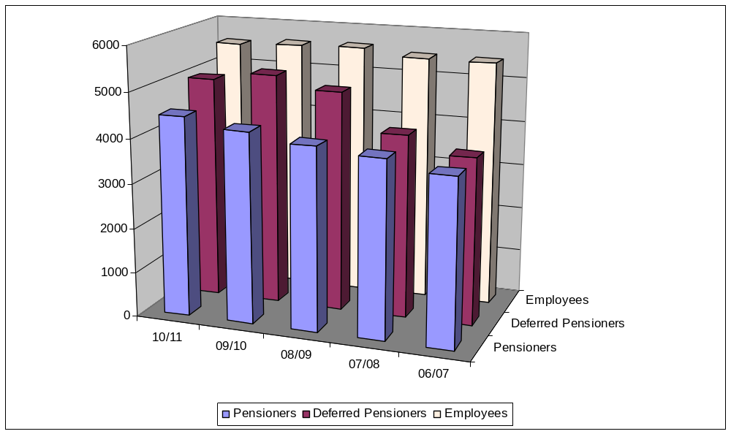

Membership Data as at 31 March 2011
 | Status | Actives | Deferreds | Pensioners | Total | %
LB Harrow | Scheduled | 5,061 | 4,629 | 4,259 | 13,949 | 92.95
Harrow College | Scheduled | 176 | 209 | 104 | 489 | 3.26
Stanmore College | Scheduled | 93 | 93 | 42 | 228 | 1.52
St Dominic's Sixth Form College | Scheduled | 38 | 19 | 19 | 76 | 0.51
Capita IT | Admitted | 12 | 4 | 5 | 21 | 0.14
Care UK | Admitted | 38 | 8 | 9 | 55 | 0.37
Harrison Catering | Admitted | 23 | 2 | - | 25 | 0.17
Julius Rutherfood | Admitted | 3 | 1 | - | 4 | 0.03
KGB Cleaning | Admitted | 2 | 1 | - | 3 | 0.02
Kier | Admitted | 7 | 2 | 1 | 10 | 0.07
North London Collegiate School | Admitted | 55 | 16 | 26 | 97 | 0.65
Supporta Care | Admitted | 39 | 3 | 8 | 50 | 0.33
Total |  | 5,547 | 4,987 | 4,473 | 15,007 | 100.00

Key Elements of the Fund

Eligibility for Membership - Virtually all employees of relevant employers (who have a contract of more than 3 months) aged under 75 can join the Fund, other than those covered by other statutory schemes (for example, teachers, police officers and fire-fighters). Membership is automatic for all employees (including those of scheduled bodies) other than employees of admitted bodies and those who have opted out in the past.

Employee Contributions – Fund changes effective from 1 April 2008 saw the introduction of banded employee contribution rates according to an employee whole time equivalent (WTE) pensionable pay. The bandings effective from 1 April 2011 are shown below:

WTE Pensionable Pay Contribution Rate
Up to £12,900 5.5%
More than £12,901 and up to £15,100 5.8%
More than £15,101 and up to £19,400 5.9%
More than £19,401 and up to £32,400 6.5%
More than £32,401 and up to £43,300 6.8%
More than £43,301 and up to £81,100 7.2%
More than £81,100 7.5%

Benefits on Retirement – From April 2008 the payment of a pension is calculated at 1/60th of the final year’s pay multiplied by the number of years service, with an option to exchange part of the pension into a tax free lump sum. The calculation of benefits in respect of pre April 2008 pensionable service is based on the accrual rate of 1/80th of the final year’s pay for each year of membership plus a lump sum of three times the pension. Actual membership may be enhanced in cases of ill health retirement. Employers may choose to augment the active members’ number of years service (other than on ill health grounds). In all cases, it is possible to exchange part of the pension for a tax free lump sum.

Age of Retirement - Normal retirement date for Fund members is at age 65, subject to:

- Pension benefits are payable at any age if retirement results from ill health.
- Members may retire with full accrued benefits from age 55 onwards if their retirement is on redundancy or efficiency grounds.
- Members who have not reached normal retirement date and to whom ill health or redundancy/efficiency retirement does not apply may elect from age 55 onwards to draw their accrued benefits. Employer consent is required for elections made before age 60, however, benefits may be actuarially reduced.

Benefits on Death in Service - A lump sum death grant is payable, normally equivalent to three years pay. Harrow Pension Fund, as administering authority, has absolute discretion over the distribution of this lump sum among the deceased’s family, dependants, personal representatives or nominated beneficiaries. Pensions may also be payable to the member’s widow, widower, civil partner, nominated partner and/or children.

Benefits on Death after Retirement - In some circumstances a lump sum death grant is payable, normally equivalent to ten times annual pension less pension paid (post April 2008 retirements). If so, Harrow Pension Fund has absolute discretion over the distribution of this lump sum among the deceased’s family, dependants, personal representatives or nominated beneficiaries. Pensions may also be payable to the member’s widow, widower, civil partner, nominated partner and/or children.

Cost of Living Increases - Pensions payable to members who retire on ill health grounds and to members’ spouses and children are increased in line with the Consumer Price Index. Pensions payable to other members who have reached the age of 55 also benefit from annual inflation proofing. Where a pensioner has a Guaranteed Minimum Pension (relating to membership up to 5 April 1997), some or all of the statutory inflation proofing may be provided by the Department for Work and Pensions.

Extra Benefits - The Fund offers several ways for members to improve benefits.

- Payment of additional periodical payments to increase annual pension;
- A money purchase AVC Fund which is operated with Equitable Life (closed to new members), Clerical Medical or Prudential.

Taxation

UK Tax - The Fund is an exempt approved fund and is therefore not liable to UK tax on capital gains and investment income. Where a taxation agreement exists between this country and another whereby a proportion of withholding tax deducted from investment income can be recovered, this will be reclaimed, although the amount and timescales vary from one country to another.

Overseas Tax – Tax arrangements outside the UK vary country by country. The Council works with fund managers and custodians to ensure advantage is taken of tax exemption rules and where tax has been deducted that reclaims are filed where permitted. The proportion reclaimable and the timescale involved is country specific.

Transfer Value Calculations-The methodology used in calculating the transfer values is in accordance with the Local Government Pensions Scheme Regulations and is also in line with the guidance received from the Government Actuarial Department.

More Information

All publications relating to the Fund, such as Harrow’s Pension Communications Policy, Fund Guides and Governance Compliance Statement, can be found on the Council website at www.harrow.gov.uk/pensions

For information on joining / leaving the Fund and Fund benefits, please contact the Pensions Section at Harrow Council.

The Council office is open from 9:00am to 5:00pm, Monday to Friday. The address is:

Shared Services – Pensions
Harrow Council
3rd Floor South Wing
Civic Centre
Station Road
Harrow
HA1 2XF

Email address: Pension@harrow.gov.uk
Telephone Number: 020 8424 1186.

For pension investments matters please contact the Corporate Finance Section, Treasury and Pensions on 020 8424 1172.

Audit Responsibilities

The Audit Commission is responsible for appointing the auditors to the London Borough of Harrow Pension Fund. For the audit of the 2010/11 accounts, Deloitte LLP have been reappointed. In future years the Council will be responsible for the selection and appointment of auditors.

Custodian

The Custodians for the Pension Fund are JP Morgan and Bank of New York Mellon. Most investments are held within pooled funds who appoint their own custodians.

The Pensions Ombudsman

The Pensions Ombudsman can investigate complaints of maladministration as well as disputes about decisions which have been made about your pension rights at the address below:

The Pensions Ombudsman
11 Belgrave Road
London SW1V 1RV

Tel No. 0207 834 9144
Fax No. 0207 821 0065
Email: enquiries@pensions-ombudsman.org.uk

Management and Investments

The Authority has delegated its responsibility for the determining of investment policy and the monitoring of investment performance to the Pension Fund Investment Panel which meets at least six times a year. The Panel sets guidelines for and assesses the investment decisions of the Fund’s investment managers.

As at 31 March 2011, the membership of the Pension Fund Investment Panel was as follows:

Councillor Dharmarajah (Chairman)
Councillor Idaikkadar
Councillor Romain
Councillor Ferrari

The membership of the panel is determined at the Annual Council meeting each May, at the start of the Council’s municipal year. A change in the membership of the panel can only be made by a Non-Executive (agreed by the Leaders of all political parties) or by full Council.

The Pension Fund Investment Panel has the following powers and duties:

- To administer all matters concerning the Council’s pension investments in accordance with the law and Council policy;
- To establish a strategy for the disposition of the Council’s Investment in accordance with the law and Council policy; and
- To determine the managers’ delegation of powers of management of the Fund.

The Pension Fund Investment Panel receives a quarterly update report on the Fund and individual fund manager’s performance.

The investment objective of the Fund is to achieve a return that is sufficient to meet the primary funding objective of minimising the level of employer contribution in order to meet the cost of pension fund benefits as required by statute, subject to an appropriate level of risk (implicit in the target) and liquidity.

The Council has delegated the management of the Fund’s investments to professional investment managers, appointed in accordance with the LGPS regulations, whose activities are specified in detailed investment management agreements and regularly monitored.

The day-to-day management of the Fund’s investments as at 31 March 2011 was carried out by the following ten external managers:

Managers | Mandate
BlackRock Investment Management (UK) Limited  State Street Global Advisors Limited | Corporate and Index linked Bonds  UK Equities Passive
Fidelity International  Wellington Management International Limited | Global Equities  Global Equities
Longview Partners Investments | Global Equities
BNY Mellon Asset Management | Active Currency
Pantheon Private Equity | Private Equity
Record Currency Management Limited | Passive Currency
Aviva Investors Global Services Limited | UK Property
UBS Global Asset Management (UK) Limited | Property

Aviva was appointed during the year to manage a property portfolio previously managed by BlackRock. Manager fees are paid as a percentage of the value of each mandate.

Investment Adviser

The Panel is advised by independent adviser, Hymans Robertson LLP.

Actuary

The actuarial service is provided by Lorna Tonner of Hymans Robertson LLP.

Actuarial Valuation

An actuarial valuation of the Fund was carried out as at 31 March 2010. The market value of the Fund’s assets at the valuation date was £436m and the total accrued liabilities of the Fund were £593m. The Fund deficit was therefore £157m producing a funding level of 73.5% (compared to 87% at 31 March 2007, the date of the last valuation).

To reach the funding level of 100% over a period of 20 years, the common employers’ contribution rate is 25.7% of pensionable pay. The Projected Unit method is used to determine this rate. Adjustments have been made to the common rate of employers’ contributions to take account of certain circumstances that are peculiar to individual employers.

The main actuarial assumptions used at 31 March 2010 are detailed below:

Assumption Nominal
Price Inflation (RPI) 3.3%
Pay Increases 4.8% [1% until 31.3.2013]
Gilt based discount rate 4.5%
Funding basis discount rate 6.1%

The next triennial actuarial valuation will be carried out as at 31 March 2013.
Statement of Investment Principles

The Local Government Pension Scheme (Management and Investment of Funds) Regulations 2009 require administering authorities to prepare, maintain and publish a written statement of principles governing their decisions about investments. The Pension Fund has adopted a formal Statement of Investment Principles which is published on the council website at www.harrow.gov.uk – Advice & Benefits - Local Government Pension Scheme – Pension Fund Policies / Statements.

The Pension Fund Investment Panel monitor’s actual against strategic asset allocations and take action when appropriate.

Funding Strategy Statement

The ‘Funding Strategy Statement’ (FSS) is a summary of the Fund’s approach to funding liabilities. It is not an exhaustive statement of policy on all issues. The purpose of the FSS is to:

- establish a clear and transparent fund-specific strategy which will identify how employers’ pension liabilities are best met going forward;
- support the regulatory framework to maintain as nearly constant employer contribution rates as possible; and
- take a prudent longer-term view of funding those liabilities.

The Pension Fund’s ‘Funding Strategy Statement’ can be found on the Council website at www.harrow.gov.uk - Advice & Benefits - Local Government Pension Scheme - Pension Fund Policies/Statements.

Funding Policy

The objectives of the Fund’s funding policy are as detailed below:

- To ensure the long-term solvency of the Fund;
- To ensure that sufficient funds are available to meet all benefits as they fall due for payment;
- To maximise investment returns for an appropriate level of risk;
- To help employers recognise and manage pension liabilities as they accrue; and
- To minimise the degree of short-term change in the level of each employer’s contributions.

Market performance

Financial markets ensured a less dramatic year in 2010/11 than the three earlier years. Global equity markets continued their recovery from the lows of March 2009 supported by continued improvements in the global economy (in particular emerging markets), robust corporate results and heightened merger and acquisition activity. However, sentiment remains fragile and markets react strongly to new economic signals. The focus of concern shifted to sovereign debt issues. The Euro zone peripheral sovereign debt crisis caused considerable concerns in financial market as Greece, Ireland and Portugal were required to accept assistance from a combined EU / IMF rescue package. The US continued its quantitative easing programme which supported modest economic growth. In the UK rising inflation mainly due to commodity prices and government spending cuts both impacted on consumer spending.

In the UK, growth proved mixed over the year. The first half of the year saw the economy outperform expectations, although it slipped into negative territory in the final quarter of 2010 due to inclement weather conditions. The year finished with prospects for the UK economy being decidedly downbeat over the short to medium term while the Japanese disasters in March, and the Arab Spring, especially the crisis in Libya, caused an increase in world oil prices, which all combined to dampen international economic growth prospects.

Global equity markets benefited from the accommodative economic policy and returned 8.4%. In the UK equity markets returned 8.7%, while those in the US and Europe (ex-UK) returned 9.6% and 7.5% respectively in sterling. Superior growth prospects in emerging markets helped them add 11.9% in the year.

Gilt yields fell for much of the first half of the year as financial markets drew considerable reassurance from the Government’s debt reduction plans, especially in the light of Euro zone sovereign debt concerns. Expectations of further quantitative easing also helped to push yields to historic lows. However, this positive performance was mostly reversed in the closing months of 2010 as sentiment changed due to sharply rising inflation pressures. These were also expected to cause the Monetary Policy Committee to start raising Bank Rate earlier than previously expected. UK gilts, index linked and corporate bonds returned 5.2%, 6.5% and 5.3% respectively. Property returned 10.7% as capital values continued to recover.

The economic outlook remains uncertain with concern that the level of economic growth will fall as monetary policy is tightened to suppress inflation and fiscal policy is tightened to address government budget deficits in developed countries. The outlook for equity markets as a whole is uncertain and much less positive than a year ago.

Fund performance

The Committee uses WM Performance Services as its independent investment performance measurer. Investment returns over 1, 3 and 5 years is shown below.

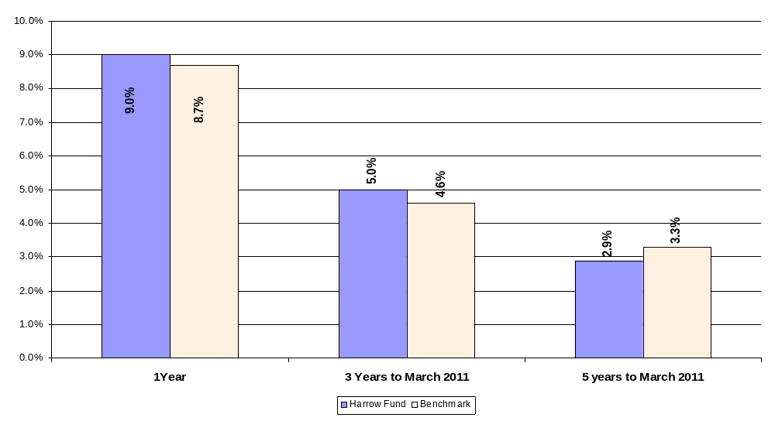

Source: WM Performance Services

The Fund benefited from the continued recovery in financial markets described above with its high allocation to equity markets and achieved a return of 9.0% in the year to 31 March 2011, outperforming the benchmark. While stock selection added value this was offset by higher than benchmark allocations to cash and private equity.

The average fund in the local authority universe (as per WM performance services) returned 8.2%, bringing 10 year returns back above inflation. The Fund return of 9.0% compared with the Local Authority Average return of 8.2%, ranking in the 22nd percentile. There were 86 funds included in the Local Authority universe at end March 2011.

The longer term performance continues to disappoint with underperformance of 0.4% over five years. The Panel expect that the changes to the investment manager structure implemented in the prior year will support improved performance.

Investment strategy

The strategic allocations approved in 2008 and reported in the Statement of Investment Principles are shown in the table below. The strategy was fully implemented in the year following the completion of a review of the manager structure.

The Panel aims to achieve its investment objective by maintaining a high allocation to growth assets, mainly equities, reflecting the security of the sponsor’s covenant, the funding level, the long time horizon of the fund and the projected asset class returns and volatility.

The Panel monitors the continued appropriateness of the strategic allocations with the next formal review due to take place following completion of the 2010 actuarial review.

Strategic Asset Allocations 31 March 2011 | %
UK Equities | 26
Global Equities | 45
Fixed and Index Linked Bonds | 13
Property | 10
Private Equity | 3
Active currency | 3
Total | 100

The actual allocations to asset classes (£’000) are shown in the chart below. The Panel monitors any divergence from strategy and rebalances when appropriate.

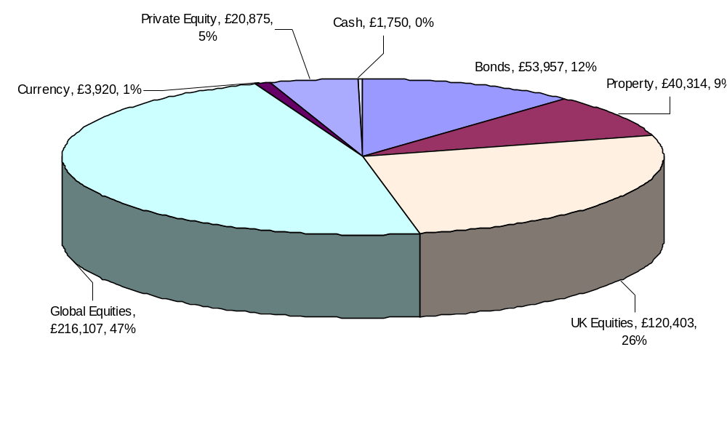

Total Value £457,326,000

Investments held by Fund Managers

 | 2010-11 |  | 2009-10
 | £000 | % | £000 | %
State Street Global Advisors | 120,397 | 26% | 117,459 | 27% | UK Equities
Longview Partners | 32,041 | 7% | 32,736 | 8% | Global Equities
Fidelity International | 86,232 | 19% | 85,927 | 20% | Global Equities
Wellington Management | 97,834 | 21% | 98,251 | 23% | Global Equities
Black Rock | 55,130 | 12% | 64,956 | 15% | Bonds
UBS | 585 | 0% | 12,771 | 3% | Property
Aviva | 40,314 | 9% | 0 | 0% | Property
Pantheon | 20,873 | 5% | 15,509 | 4% | Private Equity
Mellon | 3,020 | 1% | 2,411 | 1% | Currency
Record Currency | 900 | 0% | 1,499 | 0% | Currency
Total Fund | 457,326 | 100% | 431,519 | 100%

The above amounts include the investment assets, cash deposits and forward currency contracts included in each mandate.

One new fund manager was appointed in the year. Aviva Investors now manage the property portfolio previously managed by BlackRock. In addition, the UBS property holdings are being transitioned into management by Aviva, which will result in a single property manager.

The Panel believes in appointing fund managers with clear performance benchmarks that place maximum accountability for performance against that benchmark with the investment manager. Post the completion of the UBS transition, the Fund will have nine investment managers to give diversification of investment style and spread of risk. The Panel will continue to monitor the ability of their Investment Managers to achieve their target returns.

The Record balance comprises net derivative assets of £0.900m shown under assets (£1.527m) and liabilities (£0.627m), being the value of forward currency contracts comprising the 50% currency hedge on non-sterling investments. The hedge is designed to reduce volatility due to currency movements.

Statement of Responsibilities for the Statement of Accounts

The Council’s Responsibilities

The Council is required:

- To make arrangements for the proper administration of its financial affairs and to secure that one of its officers has the responsibility for the administration of those affairs. In Harrow, that officer is the Chief Financial Officer, i.e., the Corporate Director of Finance;

- To manage its affairs to secure economic, efficient and effective use of resources and safeguard its assets; and

- To approve the statement of accounts.

The Director of Finance’s Responsibilities

The Director of Finance is responsible for the preparation of the Fund’s statement of accounts in accordance with proper practices set out in the CIPFA Code of Practice on Local Authority Accounting.

In preparing this statement of accounts, the Director of Finance has:

- Selected suitable accounting policies and then applied them consistently;

- Made judgements and estimates that were reasonable and prudent;

- Complied with the Code of Practice on Local Authority Accounting;

- Kept proper accounting records which were up to date;

- Taken reasonable steps for the prevention and detection of fraud and other irregularities.

I certify that these accounts present fairly the financial position of the London Borough of Harrow Fund of the Local Government Pension Scheme as at 31 March 2011 and its income and expenditure for the year then ended.

Julie Alderson

INTERIM CORPORATE DIRECTOR OF FINANCE
xx^{th} September, 2011

London Borough of Harrow Pension Fund Account

Pension Fund Account for the year ended 31st March 2011

2009-10  £000 |  |  | Notes | 2010-11  £000
 |  | Contributions and Benefits
25,170 |  | Contributions receivable | 8.2 | 25,496
4,315 |  | Individual Transfers in from other schemes |  | 5,199
93 |  | Other Income (including Capital cost) |  | 31
 |  | Less:
-23,526 |  | Benefits Payable | 8.3 | -24,581
-3,805 |  | Leavers | 8.4 | -2,455
-816 |  | Administrative expenses | 8.5 | -775
1,431 |  | Net additions from dealings with members |  | 2,915
 |  | Returns on Investments
5,668 |  | Investment Income | 8.6 | 3,338
122,033 |  | Change in market value of investments | 8.7 | 33,398
-630 |  | Investment management expenses | 8.5 | 202
127,071 |  | Net returns on investments |  | 36,938
128,502 |  | Net (Increase)/decrease in Fund during the year |  | 39,853
307,421 |  | Net assets at start of year |  | 435,923
435,923 |  | Net assets at end of year |  | 475,776

Net Assets Statement

2009-10  £000 |  |  | Notes | 2010-11  £000
 |  | Investment Assets
432,893 |  | Pooled investment vehicles | 8.9 | 454,676
1,354 |  | Derivative contracts | 8.10 | 1,527
434,247 |  |  |  | 456,203
 |  | Investment Liabilities
-3,245 |  | Derivative contracts | 8.10 | -627
431,002 |  |  |  | 455,576
517 |  | Cash deposits | 8.7 | 1,750
431,519 |  | Net Investment Assets |  | 457,326
4,404 |  | Net current assets and liabilities | 8.12 | 18,450
435,923 |  | Net assets of the scheme at 31 March 2011 |  | 475,776

The accounts summarise the transactions of the Fund and deal with the net assets. They do not take account of the obligations to pay pensions and benefits which fall due after the end of the Fund year. The actuarial position of the Fund, which does take account of such obligations, is dealt with in the actuarial statement included on pages 24 and 25 and these accounts should be read in conjunction with it.

Julie Alderson

INTERIM CORPORATE DIRECTOR OF FINANCE
xx September, 2011

Notes to the Pension Fund Accounts

Accounting Policies

The accounts have been compiled in accordance with chapter 2 of the Statement of Recommended Practice “Financial Reports of Pension Schemes” (revised May 2007) (“the SORP”) and the CIPFA code of practice on local authority accounting in the United Kingdom 2009. The accounting policies have been drawn up in line with recommended accounting principles as specified in the Code of Practice on Local Authority Accounting and as disclosed below.

Basis of Preparation - Except where otherwise stated, the accounts have been prepared on an accruals basis.

Investments - These are shown in the accounts at market value which has been determined as follows:

- All listed investments are quoted at the bid price at the close of business on 31 March of each financial year;
- Unlisted securities are valued having regard to latest dealings, professional valuations, asset values, currency rates and other appropriate financial information adjusted to reflect cash transactions up to 31 March 2011;
- Investments in pooled investment vehicles are stated at the bid value of the latest prices quoted by their respective managers; and
- Derivatives are valued at the appropriate closing exchange rate or the bid spot or forward rates. Forward foreign exchange contracts are valued by determining the gain or loss that would arise from closing out the contract at the reporting date by entering into an equal and opposite contract at that date.

The change in market value of investments during the year comprises all increases and decreases in the market value of investments held at any time during the year, including profits and losses realised on sales of investments during the year. Most investments are in pooled funds where the change in market value will reflect investment income earned by the fund and fees and expenses changed to the fund.

Where appropriate, investments held in foreign currencies have been valued on the relevant basis and translated into sterling at the rate ruling on 31 March of each financial year.

Benefits, Refunds of Contributions and Transfer Values - Benefits payable and refunds of contributions are accounted for in the period in which they are payable.

Transfer values are those sums paid to, or received from, other pension schemes and relate to periods of previous pensionable employment. Transfer values have been included in the accounts on a payments and receipts basis. The transfers can take a considerable time to determine and amounts can vary depending upon the date of settlement.

Investment Income - Dividends and interest on government stocks, loans and deposits have been accounted for on an accrued basis. Foreign income has been converted into sterling at the date of the transaction.
Investment Management and Administration - Regulations published in 1989 permit the Council to charge administration costs to the Pension Fund. A proportion of the relevant Council officers’ salaries, including related on-costs, have been charged to the Fund based on estimated time spent on Fund administration and investment related business. The fees of the Fund’s investment managers have been accounted for on the basis contained within their respective management agreements.

Contributions

2009-10  £000 |  |  | 2010-11  £000
 |  | Employers - normal
16,623 |  | London Borough of Harrow | 16,905
1,367 |  | Scheduled Bodies | 1,336
530 |  | Admitted Bodies | 575
 |  | Members - normal
5,977 |  | London Borough of Harrow | 6,025
500 |  | Scheduled Bodies | 463
173 |  | Admitted Bodies | 192
25,170 |  |  | 25,496

Benefits

2009-10  £000 |  |  | 2010-11  £000
 |  | Pensions
-17,664 |  | London Borough of Harrow | -18,286
-348 |  | Scheduled Bodies | -419
-108 |  | Admitted Bodies | -134
-18,120 |  |  | -18,839
Commutation of Pensions and Lump Sum Retirement
Benefits
-4,364 |  | London Borough of Harrow | -4,847
-331 |  | Scheduled Bodies | -350
-82 |  | Admitted Bodies | -253
-4,777 |  |  | -5,450
 |  | Lump Sum Death Benefits
-629 |  | London Borough of Harrow | -292
0 |  | Admitted Bodies | 0
-629 |  |  | -292
-23,526 |  |  | -24,581

Leavers
2009-10  £000 |  |  | 2010-11
-9 |  | Refunds to members | -4
-3,797 |  | Individual transfers to other schemes | -2,451
1 |  | NI contributions | 0
-3,805 |  |  | -2,455

Investment Management and Administration Expenses

2009-10  £000 |  |  | 2010-11  £000
-630 |  | Investment management expenses | 202
 |  | Scheme administration
-690 |  | Harrow Council | -639
-126 |  | Misc. (including Actuary Fees) | -136
-816 |  | Total Administration Expenses | -775
-1,446 |  | Total Expenses | -573

Investment Income

2009-10  £000 |  |  | 2010-11  £000
889 |  | Interest from fixed interest securities | 0
3,534 |  | Dividends from equities | 0
310 |  | Income from index-linked securities | 0
1,371 |  | Income from pooled investment | 3,220
168 |  | Interest on cash deposits | 118
-604 |  | Foreign exchange | 0
5,668 |  |  | 3,338

Income from dividends has been accrued from the point when securities have been quoted ex-dividend.

Investments

 | Value at 01-Apr-10  £000 | Purchases at Cost & Derivative Payments  £000 | Sale Proceeds & Derivative Receipts  £000 | Change in Market Value  £000 | Value at 31-Mar-11  £000
Pooled Investment Vehicles
Property | 26,440 | 14,651 | -3,093 | 2,316 | 40,314
Other | 406,453 | 8,276 | -30,421 | 30,054 | 414,362
Derivatives | -1,891 | 2,190 | -427 | 1,028 | 900
 | 431,002 | 25,117 | -33,941 | 33,398 | 455,576
Cash Deposits | 517 |  |  |  | 1,750
 | 431,519 |  |  |  | 457,326

The significant change in market values is mainly due to the increase in equity values as the global economic background improved over the last year (see pages 12 & 13). Due to the pooled fund structures in use, it is not possible to separately quantify realised and unrealised gains.

Transaction costs are included in the cost of purchases and sale proceeds. Transaction costs include fees, commissions, stamp duty and other fees. There was no brokerage or custodian transaction charges incurred during the year (£0.279m in 2009-10). In addition to brokerage costs, indirect transaction costs are incurred through the bid-offer spread on investments within pooled investment vehicles. The amount of indirect costs is not separately available.

Derivative payments (£2.2m) and receipts (£0.4m) are in respect of realised losses and profits on forward foreign exchange trades settled during the period.

All fund managers operating the pooled investment vehicles are registered in the United Kingdom.

The change in market value of investments during the year comprises all increases and decreases in the market value of investments held at any time during the year, including profits and losses realised on sales of investments during the year.

Investments Exceeding 5% of the Total Value of Net Assets

2009-10  £m |  |  | 2010-11  £m
117.6 |  | SSGA MPF UK Equity Index Sub-Fund | 120.4
98.2 |  | Wellington Global Pooled Value Equity Portfolio | 97.8
74.9 |  | Fidelity Inst Select Global Pooled Equities | 86.2
40.4 |  | BlackRock Institutional Bond Fund-Corp Bond 10 Yrs A class | 43.2
32.7 |  | Longview Partners Invest - Global Pooled Equities FD K Class | 32.0
0.0 |  | Aviva Investors UK Real Estate Fund of Funds Open Ended | 30.8
363.8 |  |  | 410.4

Pooled Investment Vehicles

2009-10  £000 |  |  | 2010-11  £000
26,440 |  | UK Managed Funds - Property | 40,314
174,030 |  | UK Managed Funds - Other | 177,382
232,423 |  | Overseas Other | 236,980
432,893 |  |  | 454,676

Derivatives

2009-10  £000 |  |  | 2010-11  £000
 |  | Investment Assets
1,354 |  | Forward Foreign exchange contracts | 1,527
 |  | Investment Liabilities
-3,245 |  | Forward Foreign exchange contracts | -627
-1,891 |  | Net Derivatives | 900

Counterparty | Duration | No. of Contracts | Value at 31-Mar-11
 |  | No. of Contracts | Assets | Liabilities
 |  |  | £000 | £000
Barclays Bank - London | 7 days - 6 mths | 6 | 605 | -184
HSBC Bank - London | 7 days - 3 mths | 4 | 7 | -64
Northern Trust - London | 7 days - 6 mths | 3 | 304 | -4
Royal Bank of Scotland | 7 days - 6 mths | 4 | 33 | -4
Royal Bank of Canada - London | 7 days - 6 mths | 1 | 24 | 0
Toronto Dominion - Toronto | 7 days - 6 mths | 7 | 83 | -296
UBS AG - London | 7 days - 3 mths | 2 | 22 | -22
Westpac - Sydney | 7 days - 6 mths | 10 | 448 | -54
 |  | 37 | 1,527 | -627

The scheme objective in using derivatives is to reduce risk in the portfolio by entering into forward contracts to mitigate the effect of currency risk from overseas investments held in the portfolio without disturbing the underlying assets. The overseas equity portfolio is 50% hedged against the currency risk, and the value of the economic exposure is £142.5m.

Additional Voluntary Contributions (AVCs)

Members of the Fund make AVCs. These amounts are not included in the Pension Fund Accounts in accordance with regulation 5c of the Pension Scheme (Management and Investment of Funds) Regulations 1998.

2009-10  £000 |  |  | 2010-11  £000
2,120 |  | Value of AVC Fund at 1 April | 2,233
223 |  | Employee contributions | 249
166 |  | Investment income and change in market value | 113
0 |  | Transfer Values In | 125
-276 |  | Benefits paid and transfers out | -527
2,233 |  | Value of AVC Fund at 31 March | 2,193

Current Assets & Liabilities

2009-10  £000 |  |  | 2010-11  £000
 |  | Current Liabilities
-516 |  | Unpaid Benefits | -256
-202 |  | Other Unpaid liabilities | -175
-718 |  |  | -431
 |  | Current Assets
4,378 |  | Cash balances held by London Borough of Harrow | 18,750
114 |  | Contributions due from employers | 114
630 |  | Other Current Assets | 17
5,122 |  |  | 18,881
4,404 |  | Net Assets | 18,450

Related Party Transactions

2009-10  £000 |  |  | 2010-11  £000
16,623 |  | Employer's pension contribution to the fund | 16,905
-690 |  | Administration expenses paid to the Council | -639
4,378 |  | Cash in hand held by Council | 18,750

The fund is required under FRS8 to disclose details of material transactions with related parties.

The Council is a related party to the Pension fund. Details of the contributions made to the Fund by the Council and expenses refunded to the Council are set out above. Details of total contributions made in the year are set out in note 8.2 to the accounts.

The Pension Fund did not have a separate bank account during the year – rather cash balances are maintained by the Council on the Pension Fund’s behalf. Details of the year end cash balances maintained by the London Borough of Harrow on behalf of the Pension Fund are set out above. Separate pension fund bank accounts were implemented from 1 April 2011.

Actuarial Value of Retirement Benefits

Disclosure of the year end actuarial value of benefits calculated under IAS 19 assumptions is required by CIPFA’s Code of Practice on Local Authority Accounting 2010/11. The IAS 19 valuation is based on prescribed assumptions that differ from those used in the tri-annual valuation that determines the require level of contributions and reported on page 23 and 25.

The actuarial value of benefits and the main assumptions used by the actuary are set out below.

2009-10  £m |  |  | 2010-11  £000
757 |  | Present value of Promised Retirement Benefits | 649
3.8% |  | Inflation/ Pension Increase Rate | 2.8%
5.3% |  | Salary Increase Rate [1% p.a. until 31 March 2013] | 4.6%
5.5% |  | Discount Rate | 5.5%
The assumed average future life expectancy at age 65 was as shown in the Actuary’s statement below.

The value of the fund as at 31st March 2011 represents 73% of the actuarial value of benefits. The deficit is expected to be addressed through a combination of investment returns in excess of the discount rate and additional contributions from Employers.

Statement of the Consulting Actuary

This statement has been prepared in accordance with Regulation 34(1) of the Local Government Pension Scheme (Administration) Regulations 2008, and Chapter 6 of the CIPFA/LASAAC Code of Practice on Local Authority Accounting in the UK 2010/11.

Description of funding policy

The funding policy is set out in the Administering Authority’s Funding Strategy Statement (FSS). In summary, the key funding principles are as follows:

- to ensure the long-term solvency of the Fund as a whole and the solvency of each of the notional sub-funds allocated to the individual employers or pool of employers;
- to ensure that sufficient funds are available to meet all benefits as they fall due for payment;
- not to restrain unnecessarily the investment strategy of the Fund so that the Administering Authority can seek to maximise investment returns (and hence minimise the cost of the benefits) for an appropriate level of risk;
- to help employers recognise and manage pension liabilities as they accrue;
- to minimise the degree of short-term change in the level of employer’s contributions where the Administering Authority considers it reasonable to do so.

The FSS sets out how the Administering Authority seeks to balance the conflicting aims of securing the solvency of the Fund and keeping employer contributions stable. For employers whose covenant was considered by the Administering Authority to be sufficiently strong, contributions have been stabilised below the theoretical rate required to return their portion of the Fund to full funding over 20 years if the valuation assumptions are borne out. Asset-liability modelling has been carried out which demonstrate that if these contribution rates are paid and future contribution changes are constrained as set out in the FSS, there is still a better than 50% chance that the Fund will return to full funding over 21 years.

Funding position as at the last formal funding valuation

The most recent actuarial valuation carried out under Regulation 36 of the Local Government Pension Scheme (Administration) Regulations 2008 was as at 31 March 2010. This valuation revealed that the Fund’s assets, which at 31 March 2010 were valued at £436 million, were sufficient to meet 73.5% of the liabilities (i.e. the present value of promised retirement benefits) accrued up to that date. The resulting deficit at the 2010 valuation was £157 million.

Individual employers’ contributions for the period 1 April 2011 to 31 March 2014 were set in accordance with the Fund’s funding policy as set out in its FSS.

Principal actuarial assumptions and method used to value the liabilities

Full details of the methods and assumptions used are described in the valuation report dated 31 March 2011.

9. Statement of the Consulting Actuary (continued)

Method

The liabilities were assessed using an accrued benefits method which takes into account pensionable membership up to the valuation date, and makes an allowance for expected future salary growth to retirement or expected earlier date of leaving pensionable membership.

Assumptions

A market-related approach was taken to valuing the liabilities, for consistency with the valuation of the Fund assets at their market value. The key financial assumptions adopted for the 2010 valuation were as follows:

Financial assumptions | 31 March 2010
Financial assumptions | % p.a. Nominal | % p.a. Real
Discount rate | 6.1% | 2.8%
Pay increases * | 4.8% | 1.5%
Price inflation/Pension increases | 3.3% | -
* plus an allowance for promotional pay increases. Short term pay growth was assumed to be 1% p.a. for 2010/11, 2011/12, and 2012/13 reverting to 4.8% p.a. thereafter.
The key demographic assumption was the allowance made for longevity. As a member of Club Vita, the baseline longevity assumptions adopted at this valuation were a bespoke set of VitaCurves that were specifically tailored to fit the membership profile of the Fund. Longevity improvements were in line with standard PXA92 year of birth mortality tables, with medium cohort projections and a 1% p.a. underpin effective from 2010. Based on these assumptions, the average future life expectancies at age 65 are as follows:

 |  |  |  |  |  |  |  | Males | Females
Current Pensioners |  |  |  |  |  |  |  | 21.6 years | 23.6 years
Future Pensioners |  |  |  |  |  |  |  | 23.6 years | 25.9 years
Copies of the 2010 valuation report and Funding Strategy Statement are available on request from London Borough of Harrow, Administering Authority to the Fund.

The next actuarial valuation will be carried out as at 31 March 2013. The Funding Strategy Statement will also be reviewed at that time.

Lorna Tonner FFA
Fellow of the Institute and Faculty of Actuaries
For and on behalf of Hymans Robertson LLP

Pension Fund Annual Report Opinion

Independent auditor’s report to the Members of London Borough of Harrow Pension Fund
We have audited the pension fund accounting statements for the year ended 31 March 2010. The pension fund accounting statements comprise the Fund Account, the Net Assets Statement and the related notes 8.1 to 8.13. The pension fund accounting statements have been prepared under the accounting policies set out in the Statement of Accounting Policies.

This report is made solely to the members of London Borough of Harrow Pension Fund in accordance with Part II of the Audit Commission Act 1998 and for no other purpose, as set out in paragraph 49 of the Statement of Responsibilities of Auditors and of Audited Bodies prepared by the Audit Commission. Our audit work has been undertaken so that we might state to the Authority those matters we are required to state to them in an auditors’ report and for no other purpose. To the fullest extent permitted by law, we do not accept or assume responsibility to anyone other than the Authority, as a body, for our audit work, for this report, or for the opinions we have formed.

Respective responsibilities of the Chief Financial Officer and auditor
The Chief Financial Officer is responsible for preparing the pension fund accounting statements, in accordance with relevant legal and regulatory requirements and the Code of Practice on Local Authority Accounting in the United Kingdom 2009: A Statement of Recommended Practice. In preparing this pension fund accounting statements, the Chief Financial Officer is responsible for:
- selecting suitable accounting policies and then applying them consistently;
- making judgments and estimates that were reasonable and prudent;
- keeping proper accounting records which were up to date;
- taking reasonable steps for the prevention and detection of fraud and other irregularities.
Our responsibility is to audit the pension fund accounting statements and related notes in accordance with relevant legal and regulatory requirements and International Standards on Auditing (UK and Ireland).
We report to you our opinion as to whether the pension fund accounting statements give a true and fair view, in accordance with relevant legal and regulatory requirements and the Code of Practice on Local Authority Accounting in the United Kingdom 2009: A Statement of Recommended Practice, the financial transactions of the pension fund during the year and the amount and disposition of the fund’s assets and liabilities, other than liabilities to pay pensions and other benefits after the end of the scheme year. We also report to you whether, in our opinion, the information which comprises the commentary on the financial performance included within the Pension Fund Annual Report, is consistent with the pension fund accounting statements. That information comprises the Management Report for the year ended 31 March 2010.
We review whether the governance compliance statement published in the Pension Fund Annual Report reflects compliance with the requirements of the Local Government Pension Scheme (Administration) Regulations 2008 and related guidance. We report if it does not meet the requirements specified by the Department of Communities and Local Government or if the statement is misleading or inconsistent with other information we are aware of from our audit of the accounting statements. We are not required to consider, nor have we considered, whether the governance statement covers all risks and controls. Neither are we required to form an opinion on the effectiveness of the Authority’s corporate governance procedures or its risk and control procedures
10. Pension Fund Annual Report Opinion (continued)

We read other information published with the accounting statements and related notes as described in the contents section and consider whether it is consistent with the audited accounting statements.

Basis of audit opinion
We conducted our audit in accordance with the Audit Commission Act 1998, the Code of Audit Practice issued by the Audit Commission and International Standards on Auditing (UK and Ireland) issued by the Auditing Practices Board. An audit includes examination, on a test basis, of evidence relevant to the amounts and disclosures in the pension fund accounting statements and related notes. It also includes an assessment of the significant estimates and judgments made by the Authority in the preparation of the pension fund accounting statements and related notes, and of whether the accounting policies are appropriate to the Authority’s circumstances, consistently applied and adequately disclosed.
We planned and performed our audit so as to obtain all the information and explanations which we considered necessary in order to provide us with sufficient evidence to give reasonable assurance that the pension fund accounting statements and related notes are free from material misstatement, whether caused by fraud or other irregularity or error. In forming our opinion we also evaluated the overall adequacy of the presentation of information in the pension fund accounting statements and related notes.

Opinion
In our opinion:
- the pension fund accounting statements and related notes give a true and fair view, in accordance with the Code of Practice on Local Authority Accounting in the United Kingdom 2009: A Statement of Recommended Practice, of the financial transactions of the Pension Fund during the year ended 31 March 2010, and the amount and disposition of the fund’s assets and liabilities as at 31 March 2010, other than liabilities to pay pensions and other benefits after the end of the scheme year; and
- the information given in the commentary on financial performance included within the Pension Fund Annual Report is consistent with the pension fund accounting statements.

Paul Schofield (Engagement Lead)
For and on behalf of Deloitte LLP

Appointed Auditor

St Albans, UK

30 September 2010

